**DISCUSSIONS WITH REPRESENTATIVES OF THE TOURISM SECTOR IN THE REPUBLIC OF MOLDOVA - AN IMPORTANT OBJECTIVE OF THE ENRICHER-hubs PROJECT**

One of the objectives of the international ***ENRICHER-hubs project - "Designing Green Tourism Concepts Through Learning***” in which the European University of Political and Economic Studies Constantin Stere participates and which is part of the Erasmus+ family of projects, funded by the European Union, consisted in conducting qualitative sociological research, to elucidate unique aspects of the development of green tourism in the Republic of Moldova.

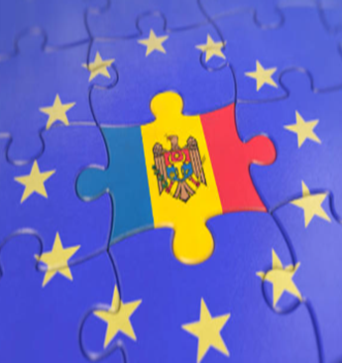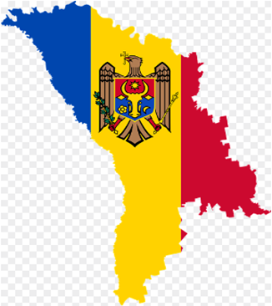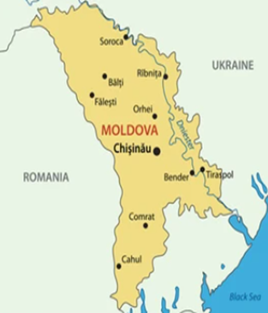

The results of the interviews conducted with representatives of the tourism sector in the country within the framework of the ENRICHER-hubs project provide a complex overview of the current situation and the development potential of green tourism in Moldova.

A range of key players in the domestic tourism industry participated in the survey – the National Tourism Office, inbound and outbound tour operators, ecotourism companies, hotels, wineries, etc. Most respondents clearly understood the concept of green tourism and its benefits to both the environment and the local economy. We believe that this has determined their positive and interested attitude towards our survey. It is worth mentioning that the interviews were conducted face-to-face, and the actors involved were guaranteed anonymity of the answers provided. As a result, the discussions were substantial and often went beyond the initial planned questions in the interview guide.

By analyzing the obtained responses, several obstacles were identified that hinder a faster transition to green tourism in Moldova, including:

* Lack of funding for investments in green infrastructure and promotional activities.
* Insufficient and inadequate legislative framework for sustainable tourism.
* Lack of knowledge and competencies in the field of green tourism at the level of tourism enterprises.
* Stiff competition from other tourist destinations.

At the same time, the interviews also highlighted several opportunities for the development of green tourism in the Republic of Moldova, such as:

* Rich natural resources and varied landscapes, which can be exploited in the context of sustainable tourism offers.
* Tourists are growing interested in authentic experiences and contact with nature.
* Potential for cooperation between different actors in the tourism sector, as well as with other sectors of the economy.

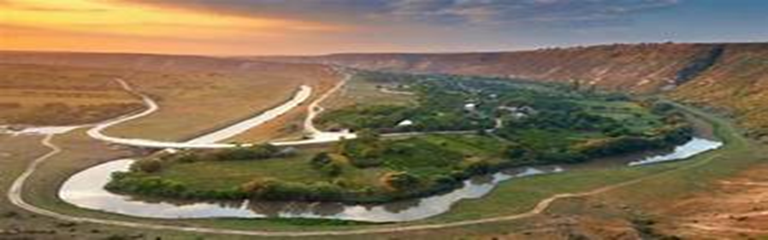

To facilitate the transition to green tourism, respondents suggested several measures, including:

* Developing a national strategy for the development of sustainable tourism.
* Providing financial and tax incentives for investments in green tourism.
* Organizing training programs and knowledge transfer in the field of sustainable tourism.
* Promoting green tourism both in the domestic and foreign markets.

The results of the interviews underline the need for an integrated and long-term approach to the development of green tourism in the Republic of Moldova. By leveraging existing potential and overcoming the identified obstacles, green tourism can become a significant engine for economic growth and improving the quality of life of the population.

Furthermore, better coordination is needed between public authorities, the private sector, non-governmental organizations, and local communities to promote green tourism.

It is crucial to allocate financial resources for the development of sustainable tourism infrastructure, such as hiking trails, bicycle paths, eco-friendly accommodation facilities, etc.

A campaign to promote green tourism in the Republic of Moldova, both on the domestic and foreign markets, is indispensable.

It is important to provide financial and technical support to tourism enterprises that wish to implement sustainable tourism practices.

We express our conviction, supported by the opinions of the interviewed respondents, that only by implementing concrete measures focused on sustainable aspects can make the Republic of Moldova a popular green tourism destination. The actors involved in the survey have undoubtedly recognized and welcomed the contribution of the ENRICHER-hubs project to achieving this goal.

